TASK**: Deploying Virtual Machines on Azure**

**Introduction**

After a class overview of cloud computing, this assignment provides basic instruction on the different ways to create and use virtual machines. For this task, we will use Microsoft azure as our cloud platform and deploy computing resources - virtual machines that use different approaches. We will create the resources using the following methods;

1. Using the portal
2. Using a template
3. Using PowerShell
4. **Creating a virtual machine in the Portal**

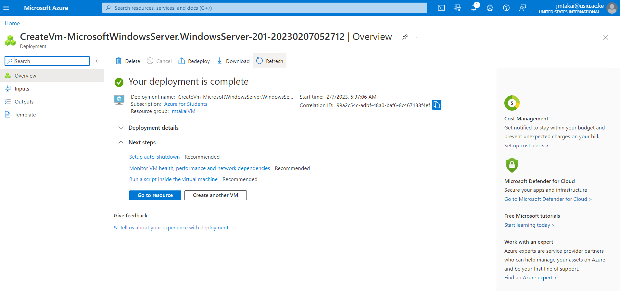

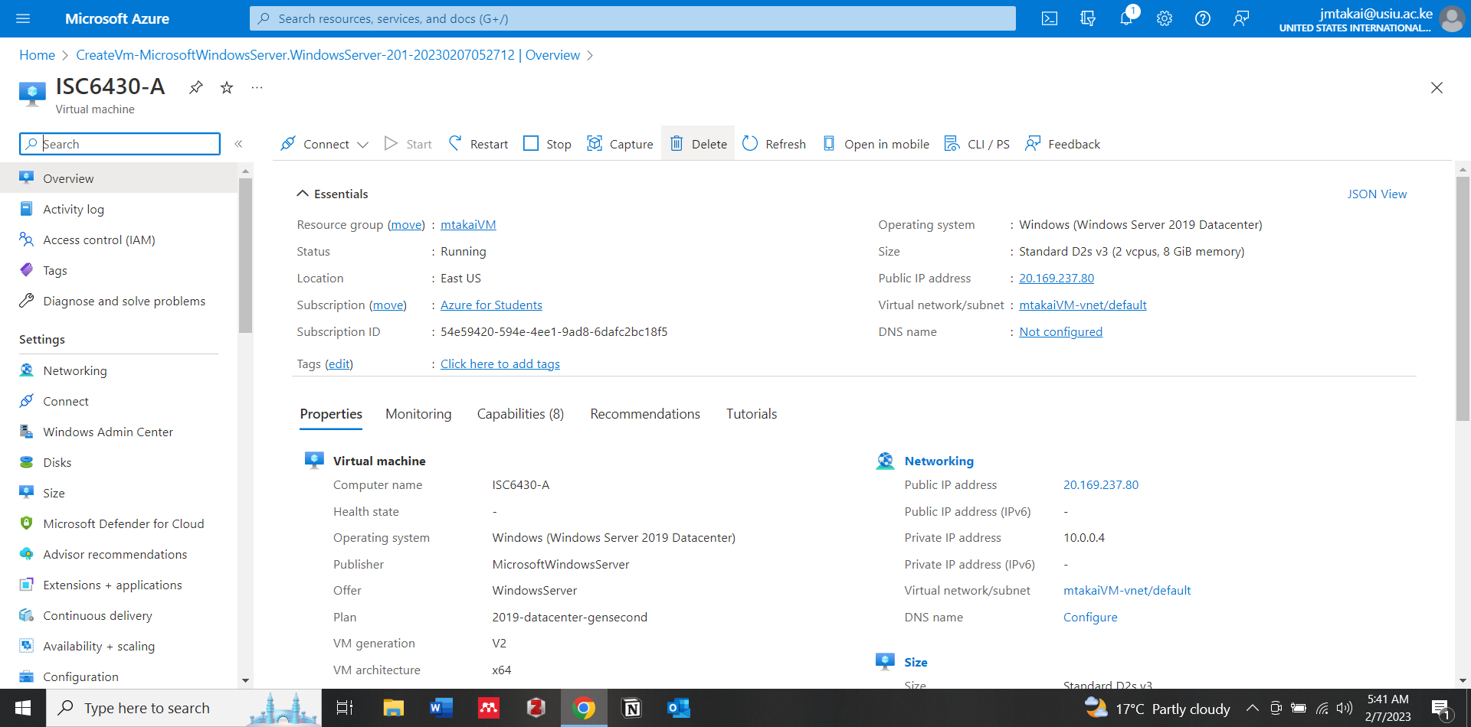

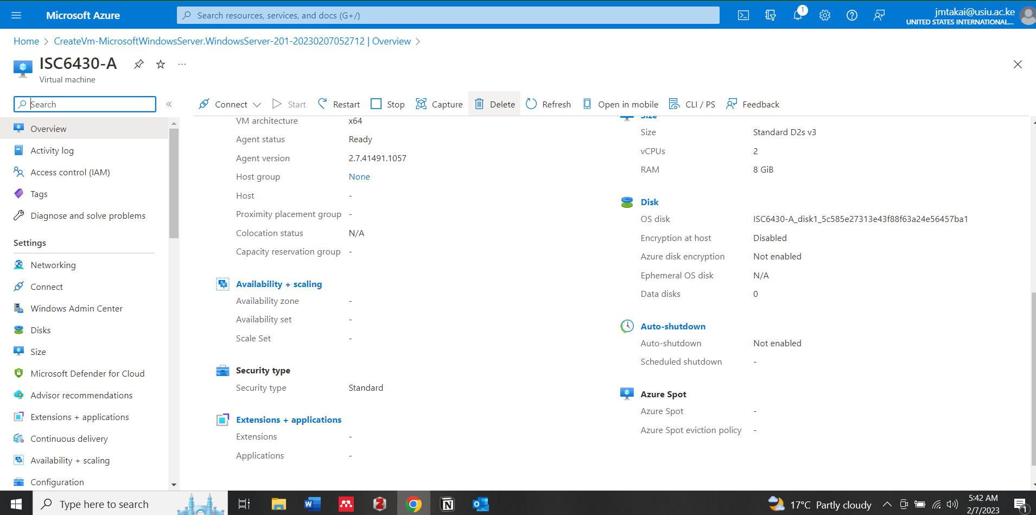

Creating and Deployment of the Virtual Machine as shown on the above figures

**Connection of the Virtual Machine from the Desktop**

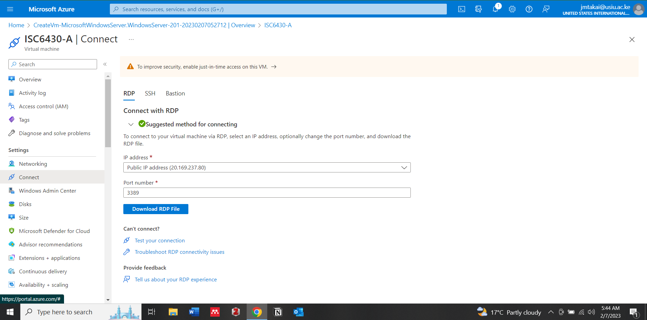

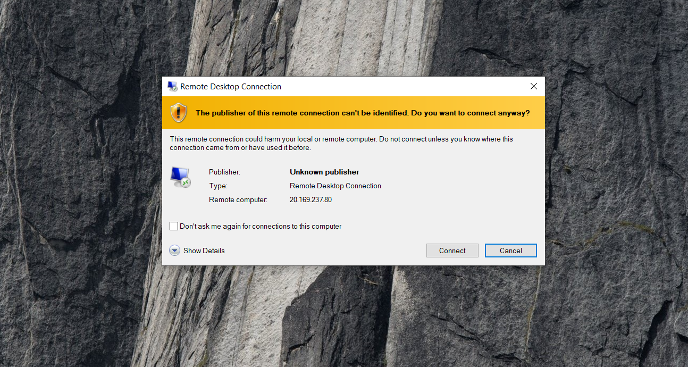

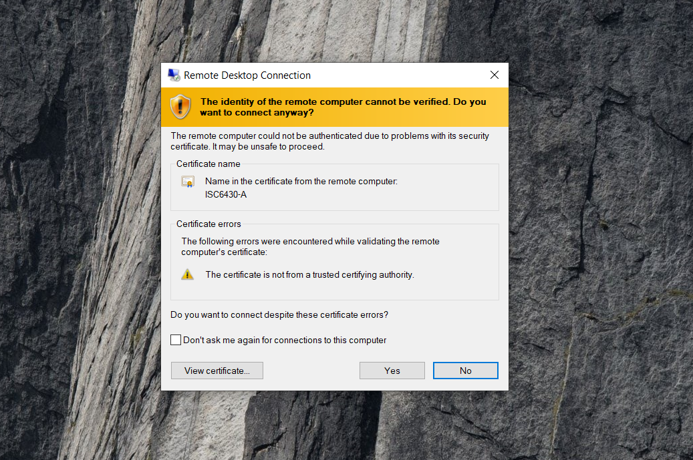

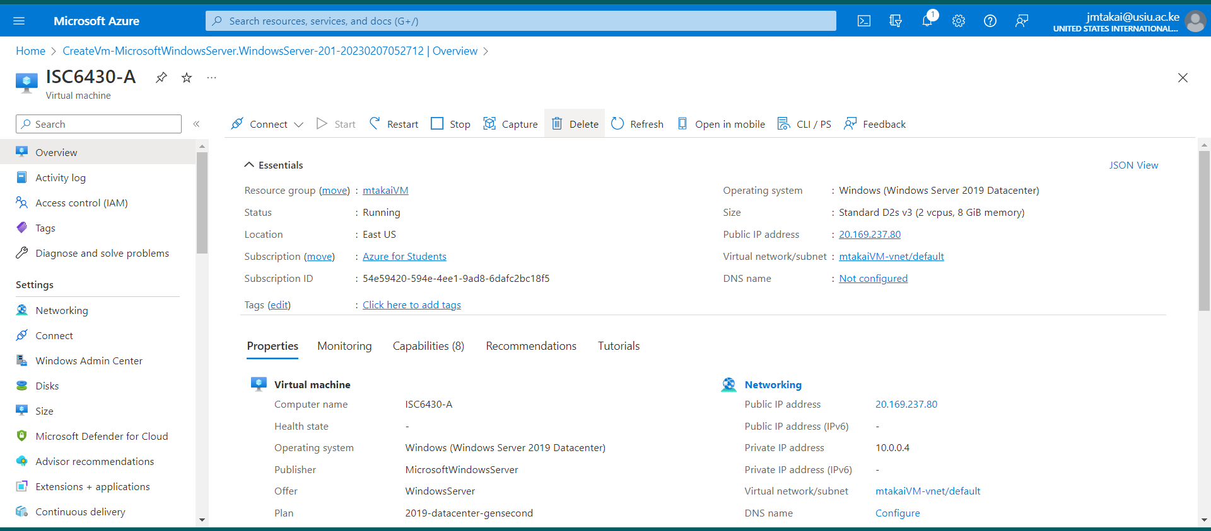

**Connection of the Virtual Machine from the Desktop**

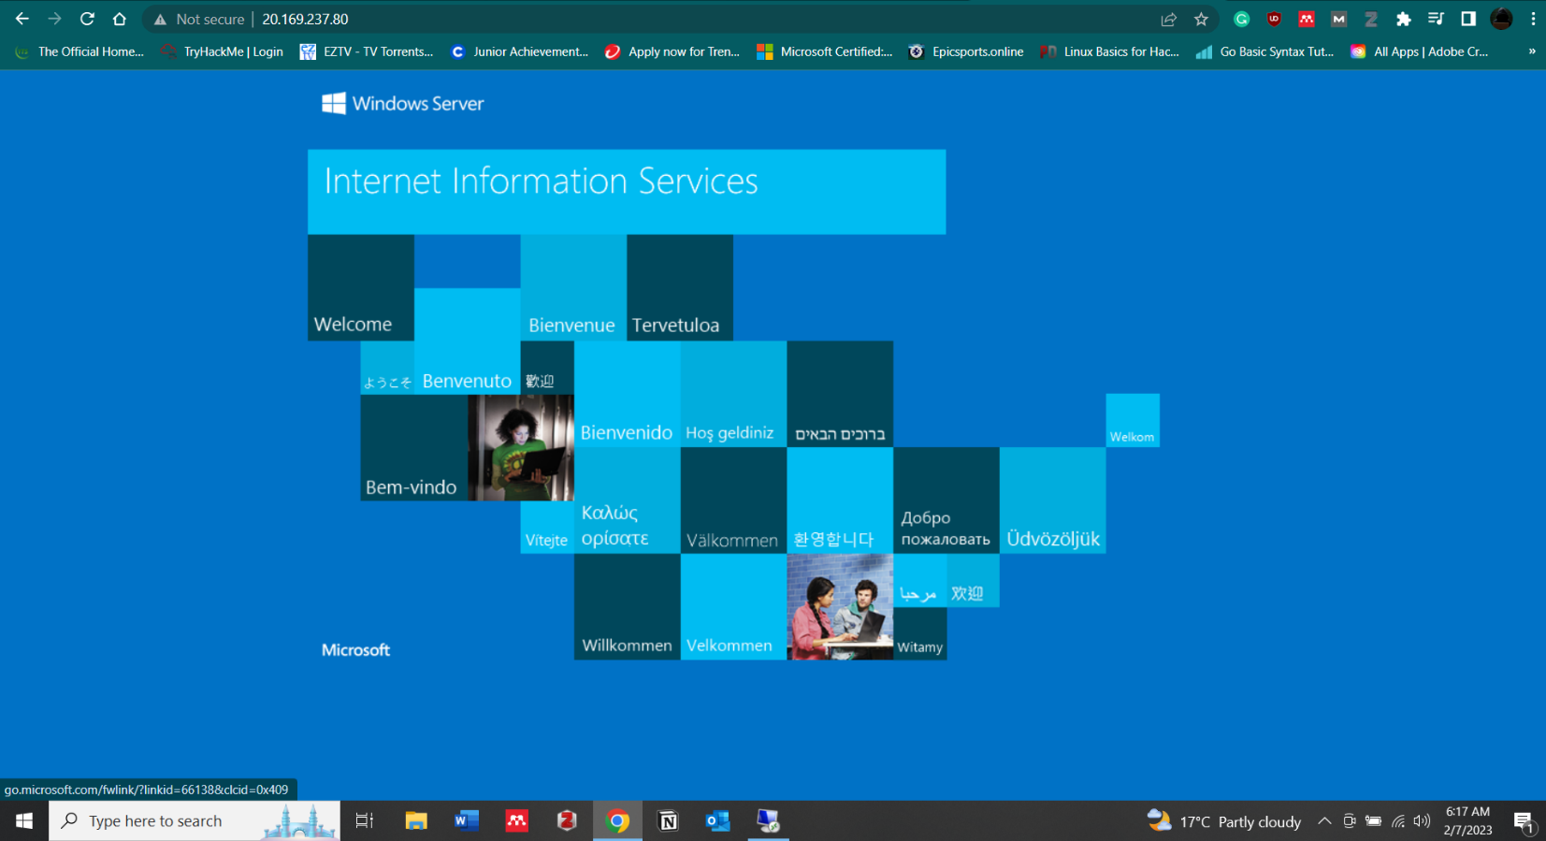

Successful connection to the Webserver

* Virtual Machine Name: **ISC6430-A**
* Username: **mtakaiVM**
* Deployment IP Address: **20.169.237.80**

1. **Create a VM with PowerShell**

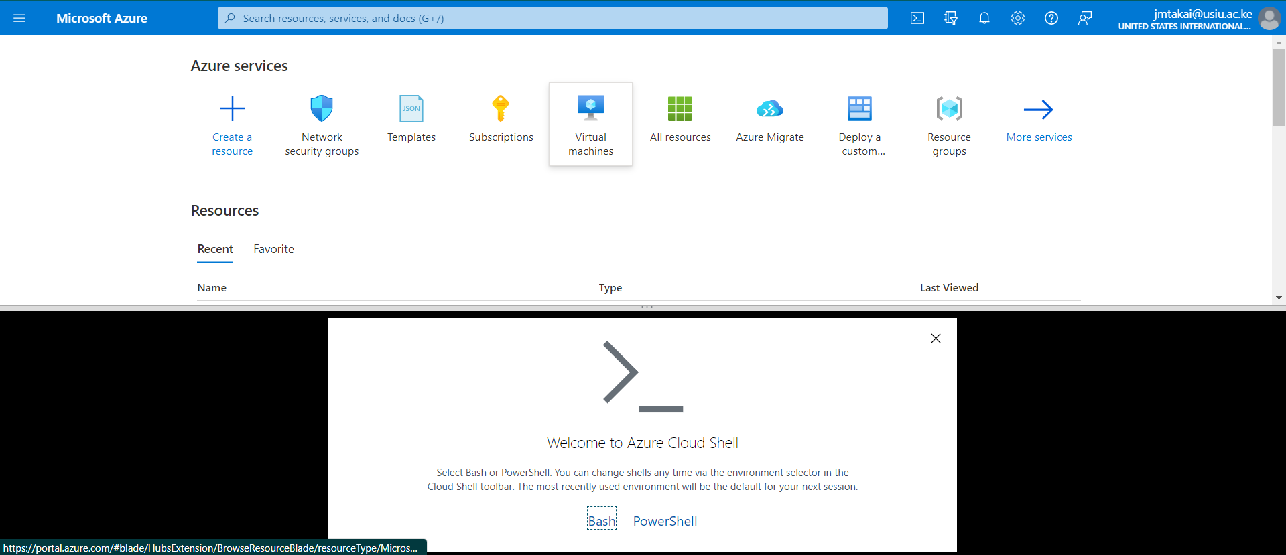

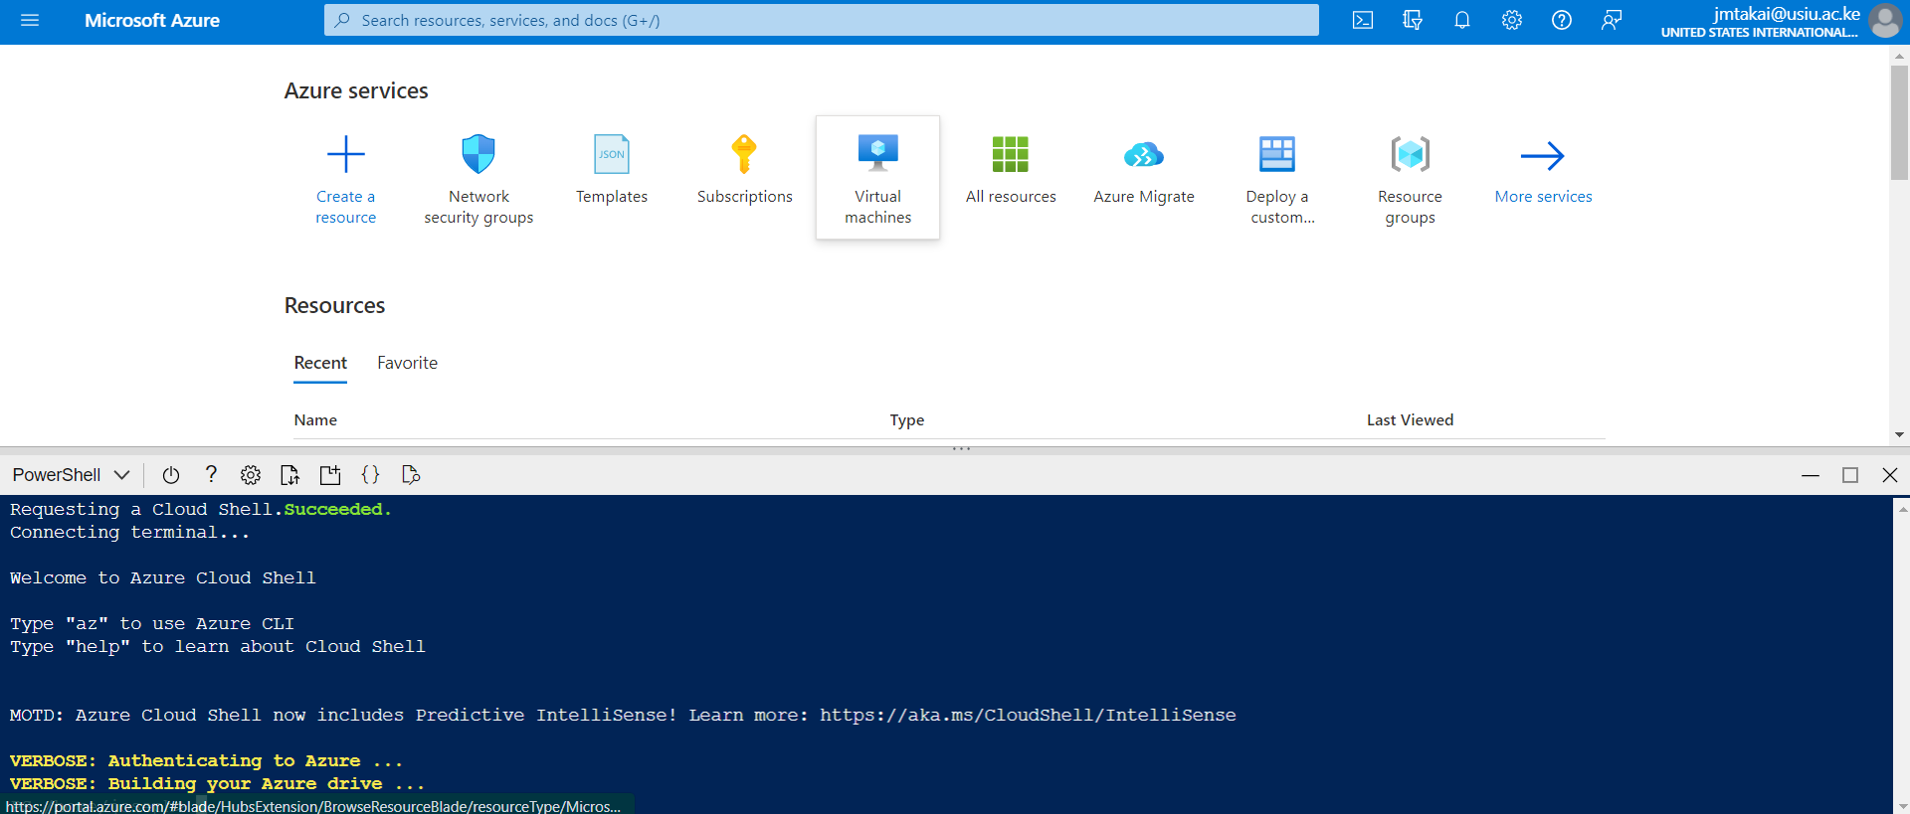

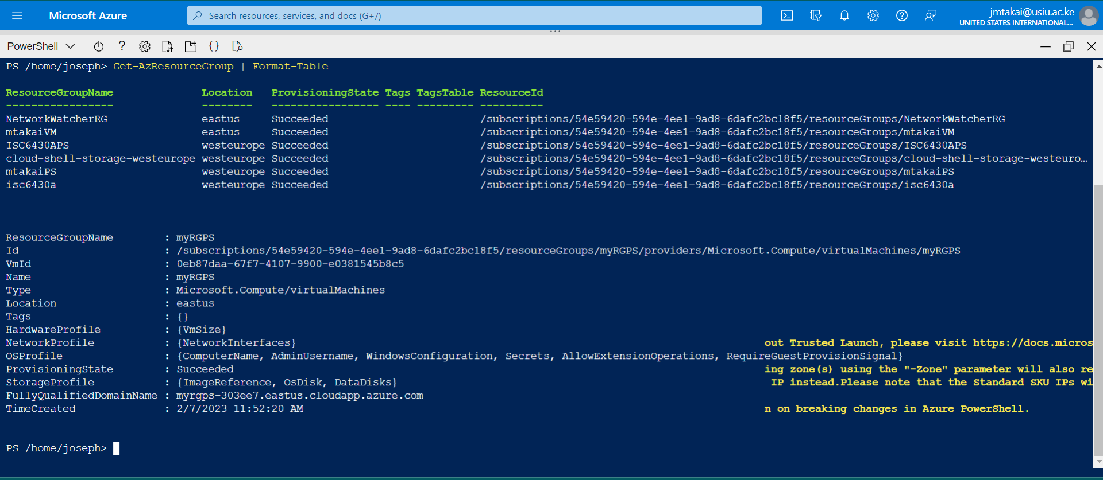

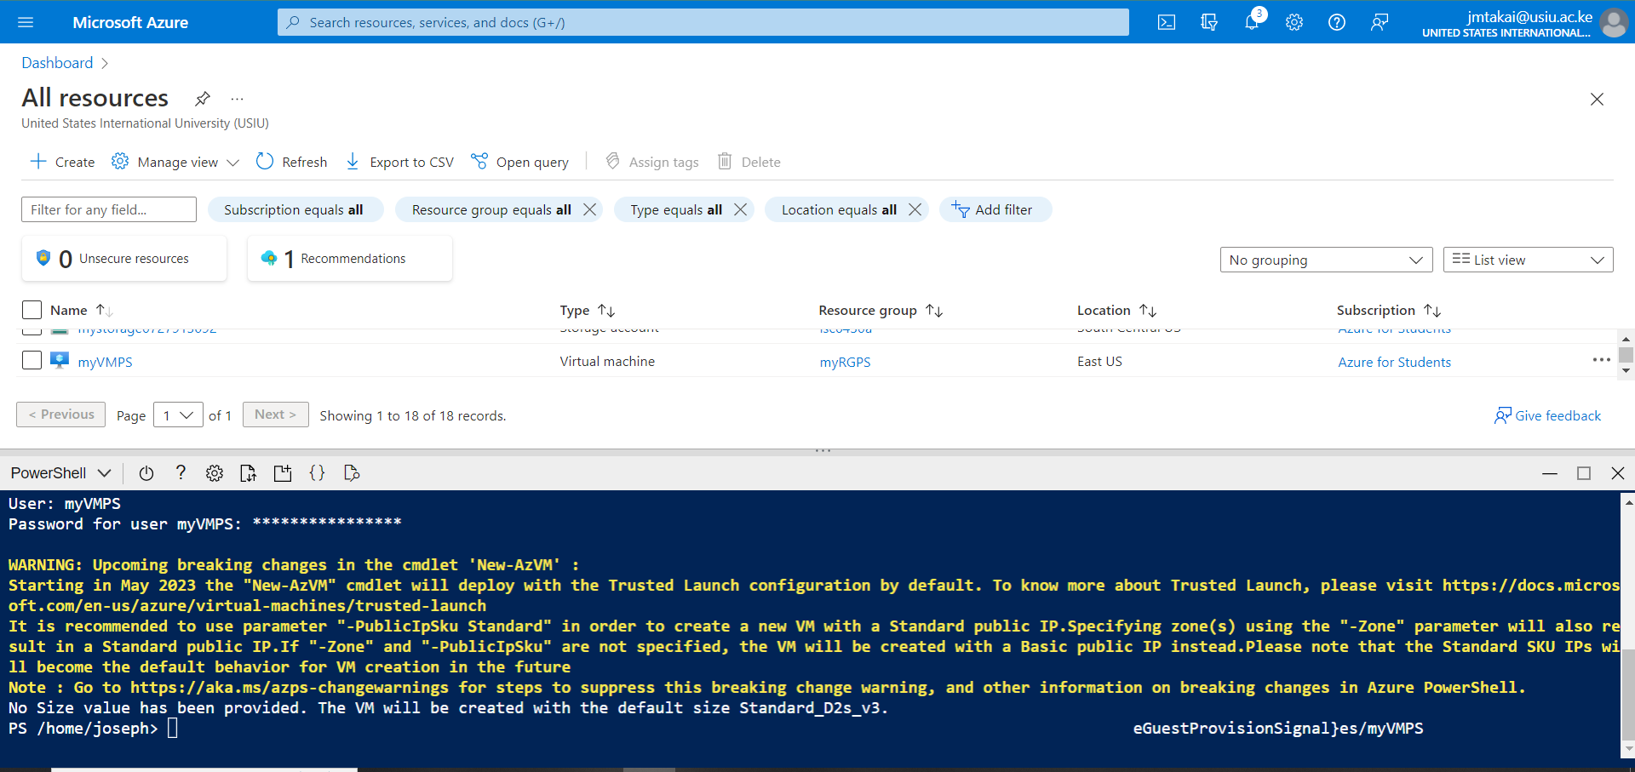

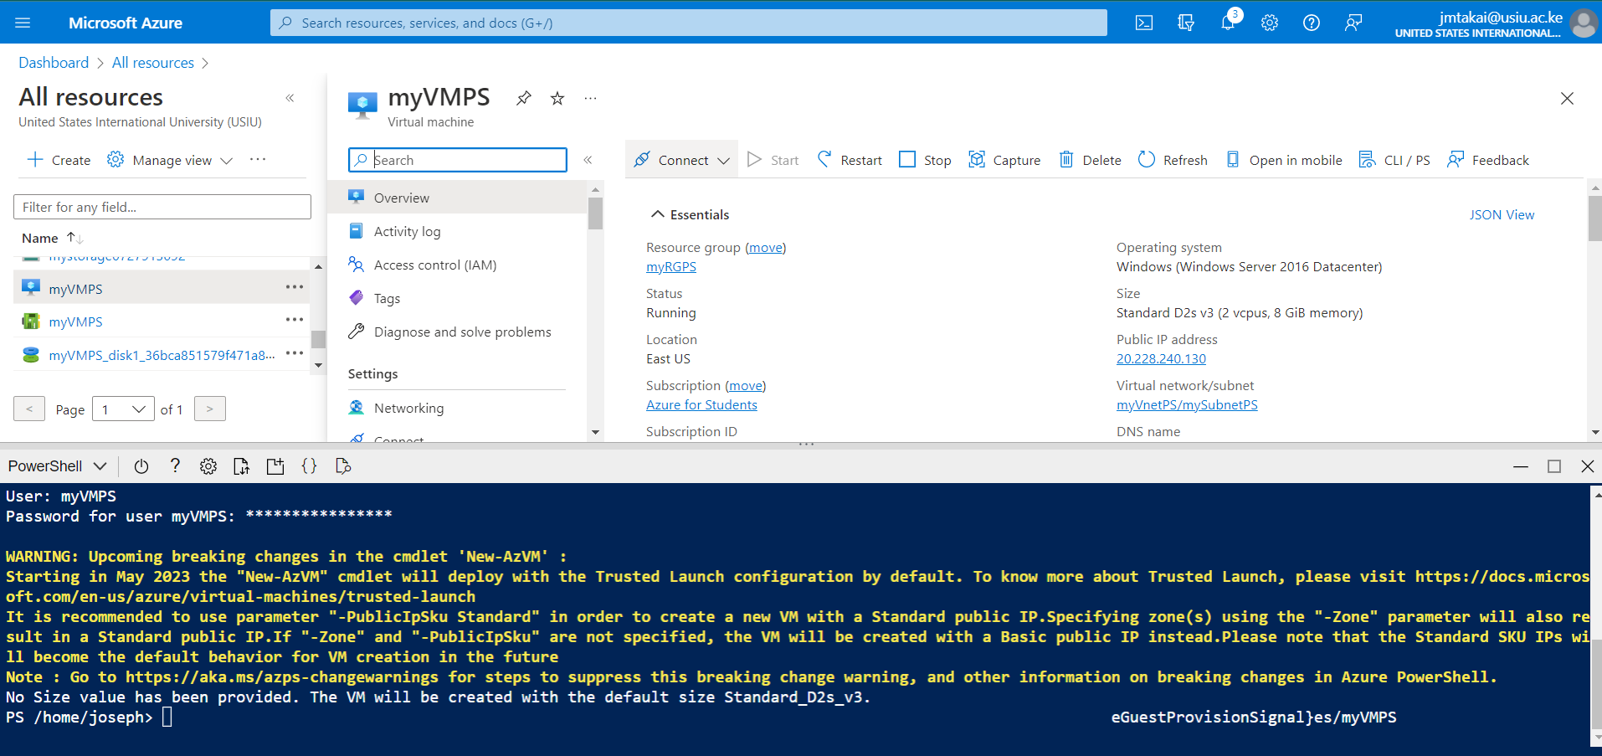

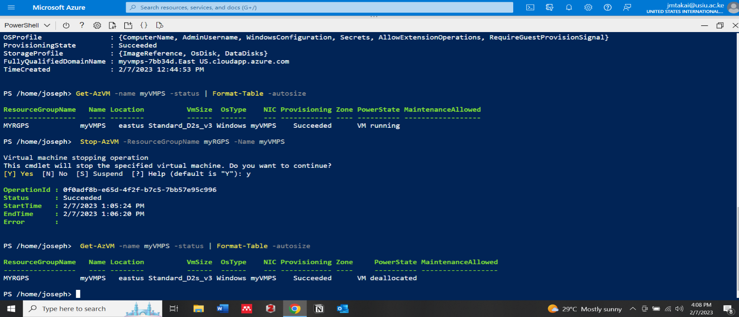

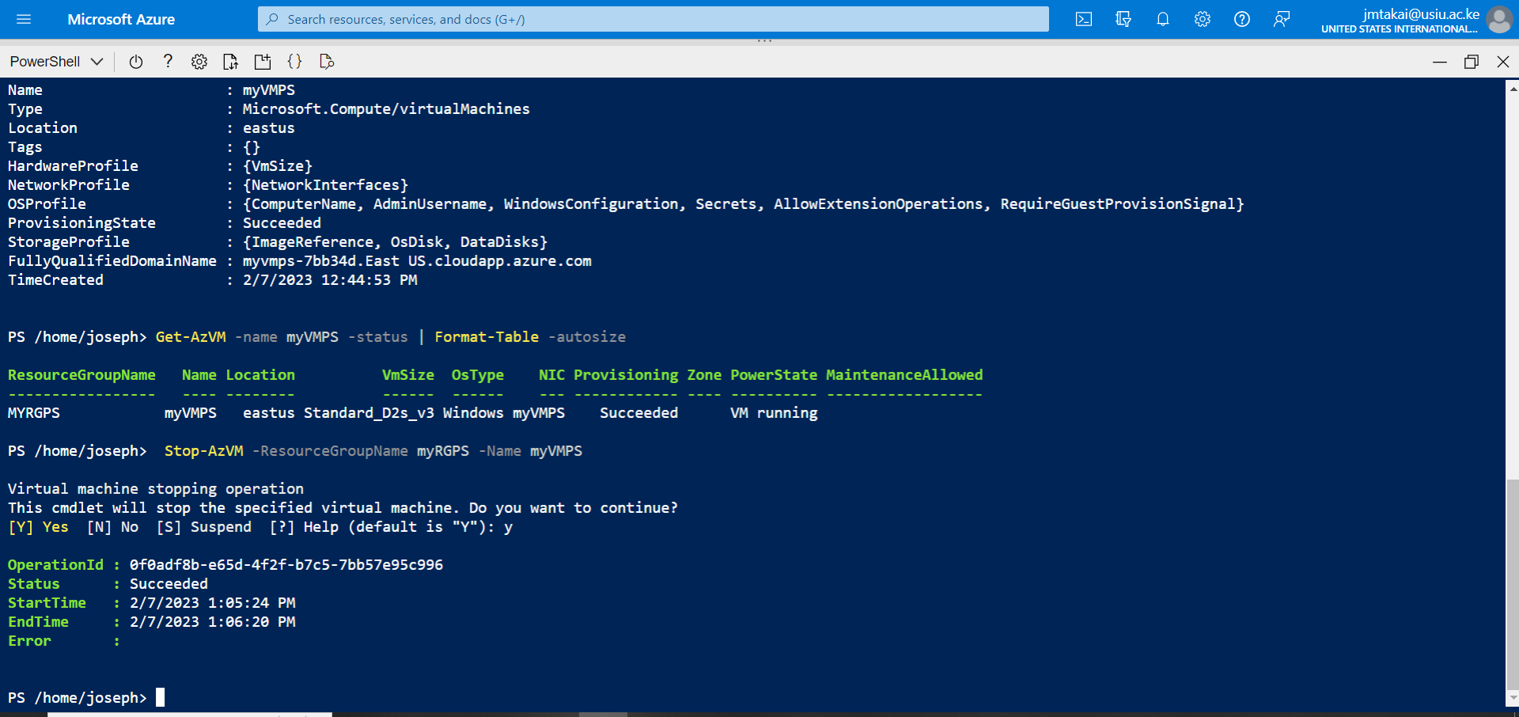

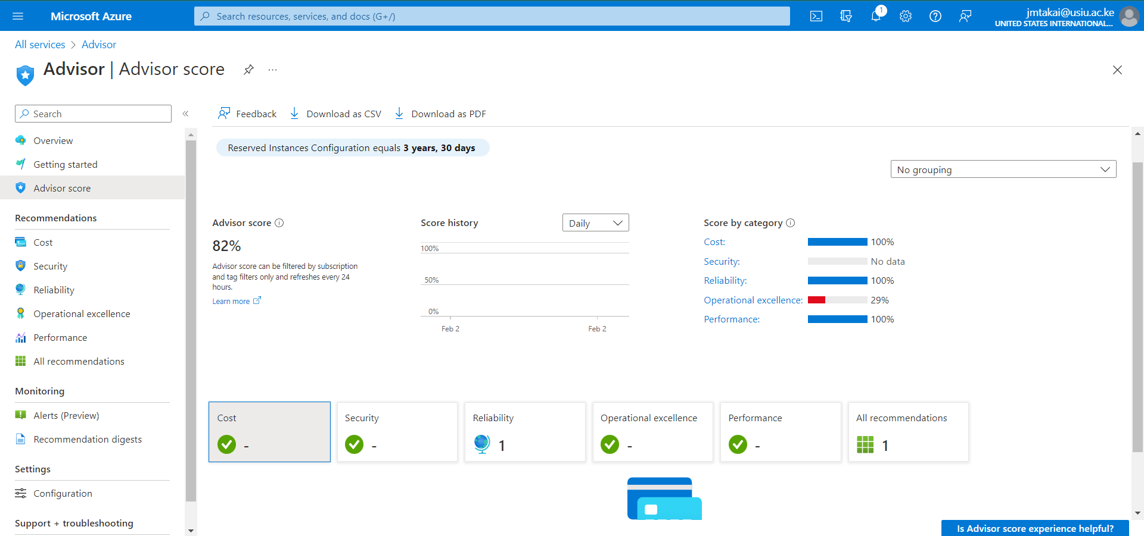

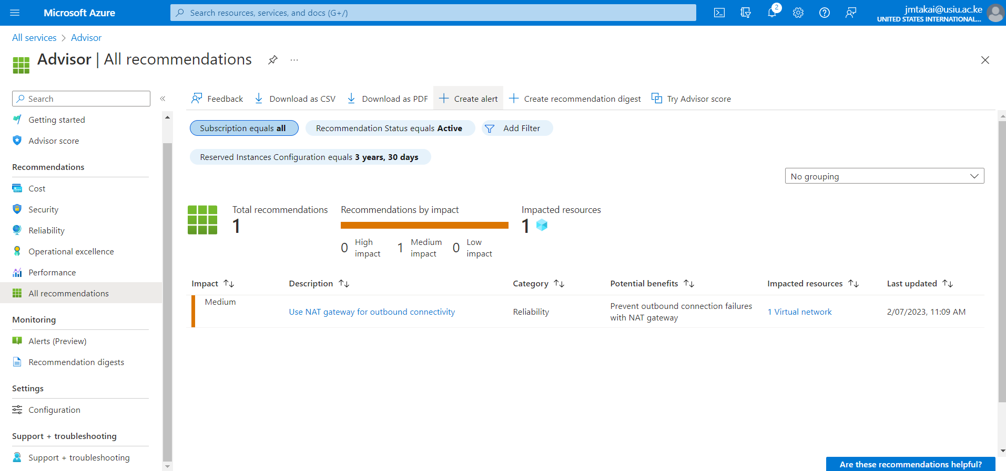

1. Creating a VM with a Template

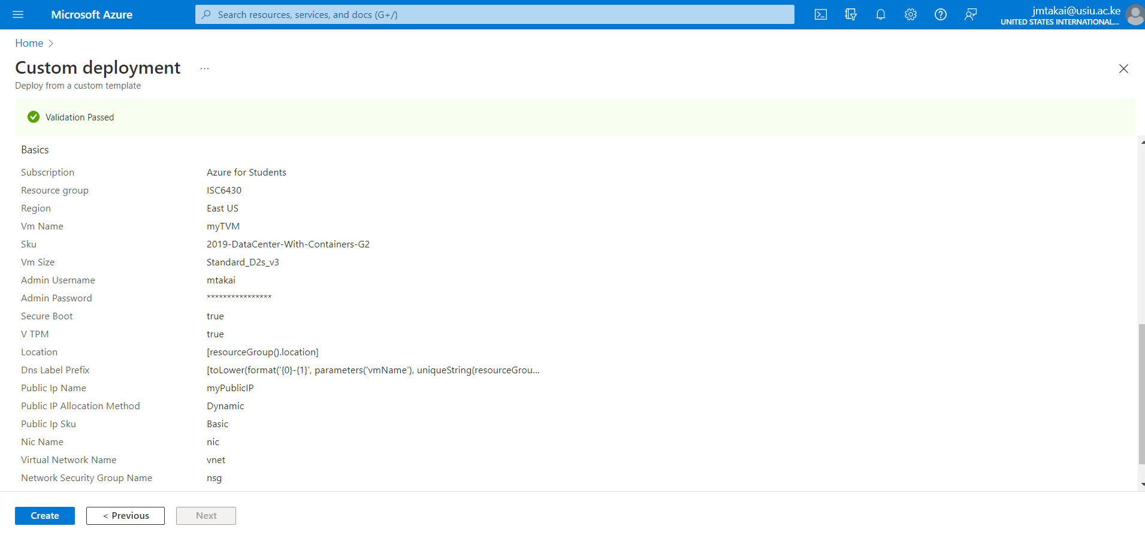

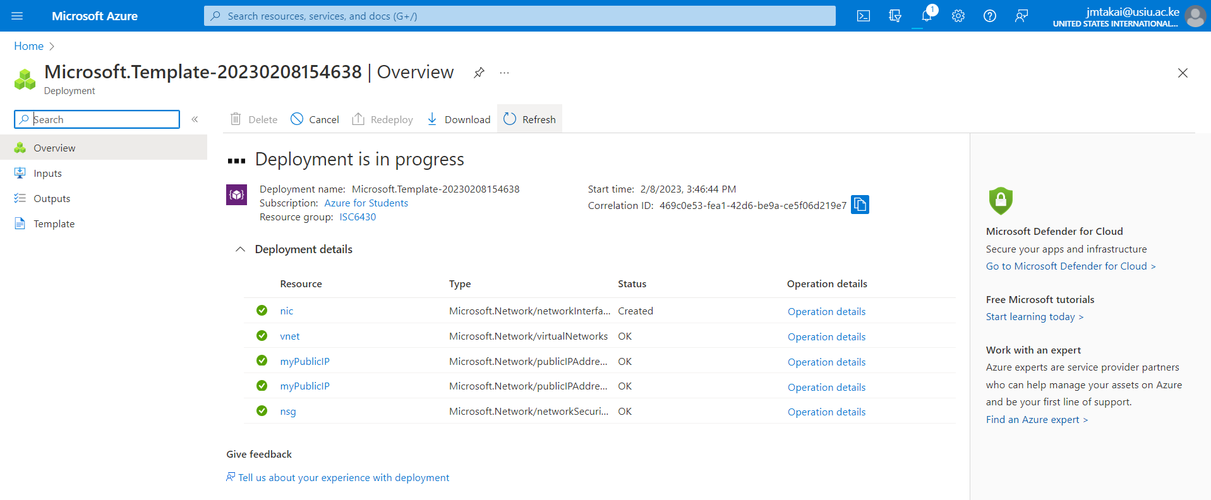

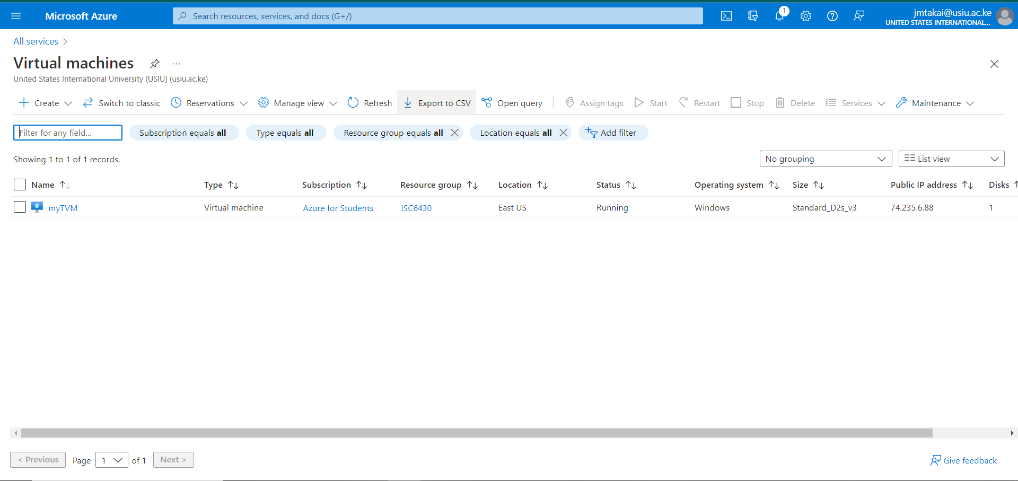

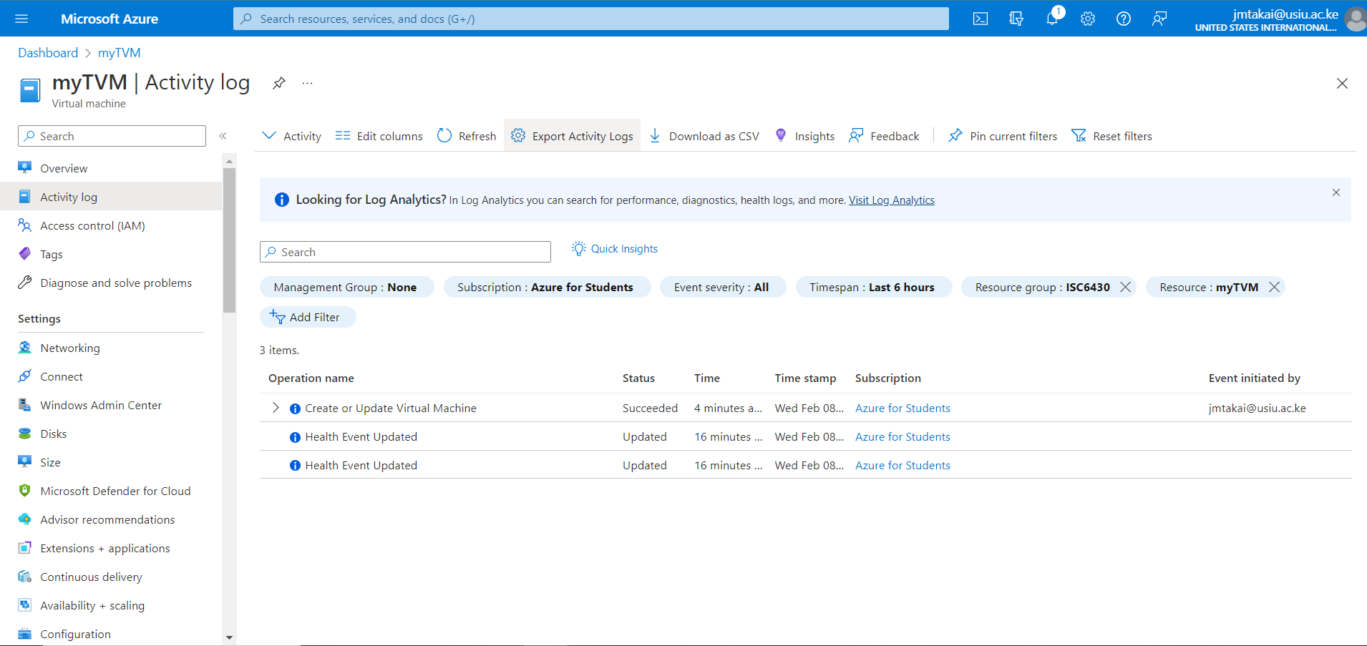

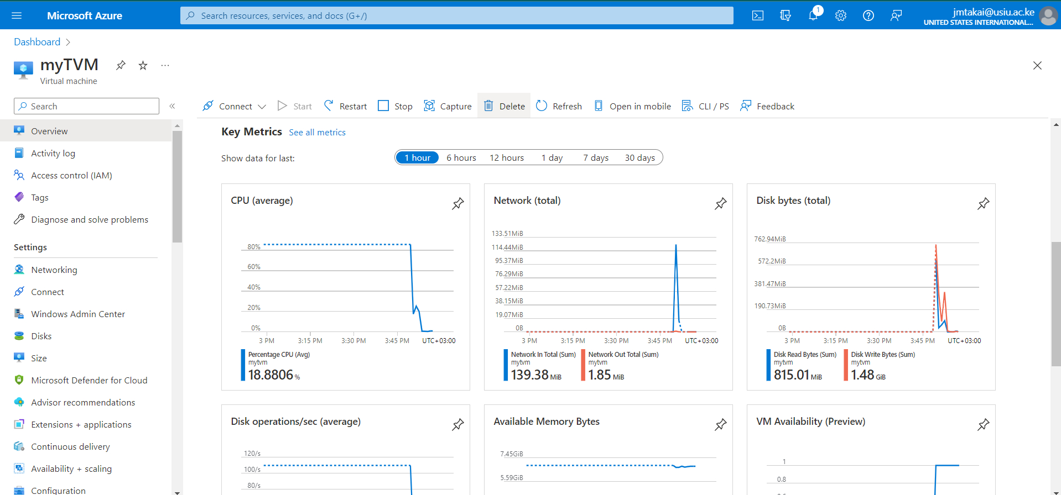

**Conclusions:**

What I have learned is that,

Accessibility, sharing, backup, and recovery of data are made simple with virtual machine solutions, providing flexibility and mobility in business operations. This not only enhances collaboration and boosts productivity, but it also aids in business continuity. The fact that virtual machines have made it possible for developers to test their work on a variety of devices and operating systems without having to purchase additional hardware is, without a doubt, this is the most significant advantage of virtual machines. This has made testing much easier to access, which has led to the development of adaptable solutions. The ability to isolate applications from one another on the network is a significant security benefit of virtualization. Data can be protected from being shared between apps and from malware or viruses that may have infected other parts of the system by keeping apps isolated.

**The five core types of virtualizations include:**

* **Hardware virtualization**: allows hardware resources to be used more efficiently. With virtualization, a single machine can run multiple different operating systems simultaneously.
* **Software virtualization**: can create a computer system featuring hardware that allows one or more guest operating systems to run on a physical host machine. can also virtualize applications and deliver them from a server to an end user’s device, allowing employees to access centrally hosted applications when working remotely.
* **Storage virtualization**: can speed up performance, enhance load balancing, and cut costs by combining multiple physical storage devices to appear as one. It is helpful for disaster recovery planning and helps to minimize downtime. It can be quickly duplicated and transferred to a different location.
* **Network virtualization**: combines equipment into a single software-based virtual network. Businesses can enjoy the advantages of increased reliability, network speed, security and improved monitoring of data usage. It allows available bandwidth to be divided into multiple, independent channels, each of which can be assigned to servers and devices in real time.
* **Desktop virtualization**: is one of the most common types of virtualizations. It separates the desktop environment from the hardware of a computer onto a remote server. Users will benefit from easy accessibility, better data security, ease of management and the cost savings of software licenses and updates.